ISO/WD 18582-3
ISO TC 131/SC 1/WG 4
Date: 2022-08
ISO/WD 18582-3, Fluid power — Specification of reference dictionary — Part 3: Definitions of classes and properties of hydraulics
Transmissions hydrauliques et pneumatiques — Spécification d'un dictionnaire de référence — Partie 3: Définitions des classes et propriétés relatives aux transmissions hydrauliques

WD stage

Warning for WDs and CDs
This document is not an ISO International Standard. It is distributed for review and comment. It is subject to change without notice and may not be referred to as an International Standard.
Recipients of this draft are invited to submit, with their comments, notification of any relevant patent rights of which they are aware and to provide supporting documentation.

A model manuscript of a draft International Standard (known as “The Rice Model”) is available at https://www.iso.org/iso/model_document-rice_model.pdf

All rights reserved. Unless otherwise specified, or required in the context of its implementation, no part of this publication may be reproduced or utilized otherwise in any form or by any means, electronic or mechanical, including photocopying, or posting on the internet or an intranet, without prior written permission. Permission can be requested from either ISO at the address below or ISO’s member body in the country of the requester.
ISO copyright office
CP 401 • Ch. de Blandonnet 8
CH-1214 Vernier, Geneva
Phone: +41 22 749 01 11
Email: copyright@iso.org
Website: www.iso.org
Published in Switzerland
Contents
Foreword iv
Introduction v
1 Scope 1
2 Normative references 1
3 Terms and definitions 1
4 General principles 1
4.1 Application Classes 1
4.2 Properties 1
4.3 Assignment properties to classes 2
5 Access to the tables 2
5.1 General 2
5.2 Link to the ISO Standards Maintenance Portal 2
Bibliography 3

Foreword
ISO (the International Organization for Standardization) is a worldwide federation of national standards bodies (ISO member bodies). The work of preparing International Standards is normally carried out through ISO technical committees. Each member body interested in a subject for which a technical committee has been established has the right to be represented on that committee. International organizations, governmental and non-governmental, in liaison with ISO, also take part in the work. ISO collaborates closely with the International Electrotechnical Commission (IEC) on all matters of electrotechnical standardization.
The procedures used to develop this document and those intended for its further maintenance are described in the ISO/IEC Directives, Part 1. In particular, the different approval criteria needed for the different types of ISO documents should be noted. This document was drafted in accordance with the editorial rules of the ISO/IEC Directives, Part 2 (see www.iso.org/directives).
Attention is drawn to the possibility that some of the elements of this document may be the subject of patent rights. ISO shall not be held responsible for identifying any or all such patent rights. Details of any patent rights identified during the development of the document will be in the Introduction and/or on the ISO list of patent declarations received (see www.iso.org/patents).
Any trade name used in this document is information given for the convenience of users and does not constitute an endorsement.
For an explanation of the voluntary nature of standards, the meaning of ISO specific terms and expressions related to conformity assessment, as well as information about ISO's adherence to the World Trade Organization (WTO) principles in the Technical Barriers to Trade (TBT), see www.iso.org/iso/foreword.html.
This document was prepared by Technical Committee ISO/TC 131, Fluid power systems, Subcommittee SC 1, Symbols, terminology and classifications.
A list of all parts in the ISO 18582 series can be found on the ISO website.
Any feedback or questions on this document should be directed to the user’s national standards body. A complete listing of these bodies can be found at www.iso.org/members.html.

Introduction
This document provides sufficient detail of information required for an unambiguous electronic data exchange for the business area of hydraulic fluid power systems. ISO 5598 provides only terms and definitions for fluid power in general which is not sufficient for electronic data exchange.

Fluid power — Specification of reference dictionary — Part 3: Definitions of classes and properties of hydraulics

Scope
This document specifies a reference dictionary of standardized product properties for the area of hydraulic fluid power on the basis of ISO 18582-1.
The properties are determined on the basis of standardized attributes.

Normative references
The following documents are referred to in the text in such a way that some or all of their content constitutes requirements of this document. For dated references, only the edition cited applies. For undated references, the latest edition of the referenced document (including any amendments) applies.
ISO/IEC Guide 77-2, Guide for specification of product properties and classes — Part 2: Technical principles and guidance
ISO 5598, Fluid power systems and components — Vocabulary
ISO 13584-42, Industrial automation systems and integration — Parts library — Part 42: Description methodology: Methodology for structuring parts families

Terms and definitions
For the purposes of this document, the terms and definitions given in ISO 13584-42 and ISO/IEC Guide 77-2 apply.
ISO and IEC maintain terminology databases for use in standardization at the following addresses:
- ISO Online browsing platform: available at https://www.iso.org/obp
- IEC Electropedia: available at https://www.electropedia.org/

General principles
In contrast to ISO 18582-2, the assignment of hydraulic properties to definition classes was dispensed with. Instead, the properties are assigned directly to application classes that could be used immediately in a user's system.
The application classes, the properties and the assignment of properties to application classes are listed in separate tables

Application Classes
The application classes are hierarchically structured in 4 levels and are intended to represent a comprehensive mapping of hydraulics. The representation of each application class has been reduced to 3 attributes, namely "identifier", "preferred name" and "definition".

Properties
The properties are described with a largely complete set of attributes according to ISO 18582-1 and ISO 18582-2.

Assignment properties to classes
The assignment of properties to application classes is displayed in the form of a table so that the list of properties assigned to an application class can be read in the respective column. It is also possible to read the list of application classes to which the property has been assigned in the respective row.

Access to the tables

General
The three tables described in 4.1, 4.2 and 4.3 are Excel Files. These Excel tables are stored in specific ISO repositories freely accessible online.

Link to the ISO Standards Maintenance Portal
The SM2 Catalogue tables are accessible by the following URL to the ISO Standards
Maintenance Portal (see Figure 1):
https://standards.iso.org/iso/

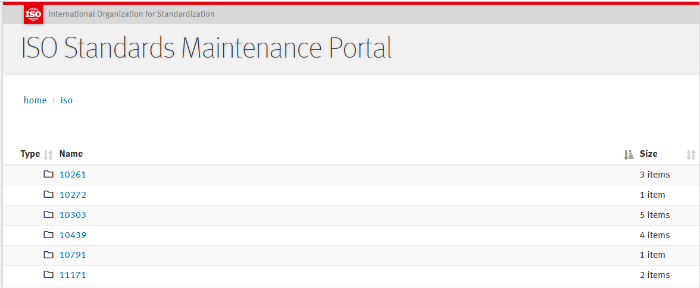
.
.
.
Figure 1 – ISO Standards Maintenance portal
Remark :
Right now, the 18582 has not yet been added to the portal. Only when ISO 18582-3 has reached IS status will it be included in the portal. Before being added to the portal, the Excel table is added to this document as a separate document.

Bibliography
[1] ISO 18582-1:2016, Fluid power — Specification of reference dictionary — Part 1: General overview on organization and structure
[2] ISO 18582-2:2018, Fluid power — Specification of reference dictionary — Part 2: Definitions of classes and properties of pneumatics

