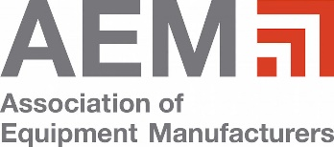 |  | 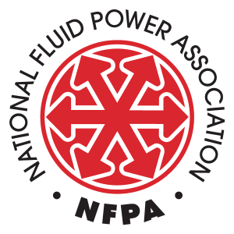
Quarterly Conference
Increasing Efficiency and Reducing Emissions with Electric-Powered Hydraulics on Mobile Machines
Co-organized by:
Association of Equipment Manufacturers (AEM)
MSOE’s Fluid Power Industrial Consortium (FPIC)
National Fluid Power Association (NFPA)
Thursday, September 1, 2022
8:00 AM to 12:30 PM Central Time
CURRENT SCHEDULE as of JULY 20, 2022
ALL TIMES CENTRAL

8:00 AM to 8:10 AM Connection Time/Prepare for Event

We want to make sure everyone is connected and ready to go for an informative and interactive morning. Ise this time to make sure your connection is working, familiarize yourself with the virtual platform, and connect informally with other participants via the virtual networking tables.

8:10 AM to 8:30 AM Welcome and Opening Remarks

Jon Somers (AEM), Sheku Kamara (MSOE), and Eric Lanke (NFPA) will call us to order and provide an overview of today’s program and the supporting organizations.

8:30 AM to 9:20 AM State of Play: Electrification of Mobile Machines
Member of AEM Task Force

A member of AEM’s Task Force will present information to better contextualize the reasons why mobile machines are electrifying, what efficiency and emission goals have been identified by the industry, and what electric technologies are being considered.

9:20 AM to 9:30 AM Networking Break

Use this time to attend to other details of your morning or network with other attendees via the virtual networking tables.

9:30 AM to 10:20 AM Hyper Efficiency with Power-on-demand Electro-hydraulics on Hybrid, Fuel Cell, and Battery-powered Mobile Machines
Mike Terzo, CEO, Terzo Power Systems

What is possible in terms of efficiency and emissions reductions? Efficient hydraulic systems are critical for electrified mobile machinery to extend range or runtime and this presentation will cover cutting edge electro-hydraulic technologies while exploring just how far we can go when powering hydraulics off an electric source.

10:20 AM to 10:30 AM Networking Break

Use this time to attend to other details of your morning or network with other attendees via the virtual networking tables.

10:30 AM to 11:20 AM Lower Emissions in Turf Care Applications Through Hybrid Hydro-Electric Systems
Dave Heiling, Engineered Systems and Solutions R&D Manager, Nott Company

Lower emission solutions for turf care applications can be developed using a hybrid hydraulic/electric strategy. Modern battery technology, utilizing a low voltage/high current approach can optimize power consumption and reduce overall emissions, system maintenance costs and noise. This basic strategy is easily extended into applications with similar duty cycles.

11:20 AM to 11:30 AM Networking Break

Use this time to attend to other details of your morning or network with other attendees via the virtual networking tables.

11:30 AM to 12:20 PM Launch of NFPA’s Electrification in Fluid Power Task Force
Eric Lanke, President/CEO, National Fluid Power Association

Eric will lead an introductory session for those who have joined or who are interested in joining the new NFPA Electrification in Fluid Power Task Force – an industry working group that will explore and define multiple electrification architectures and seek to describe their potential impacts on the fluid power industry and the mobile and industrial markets it serves.

12:20 PM to 12:30 PM Wrap-Up and Closing

Jon Somers (AEM), Sheku Kamara (MSOE), and Eric Lanke (NFPA) will provide some summary comments, answer any questions, and thank everyone for participating.

